Turck PS+ Full AOI Design

Part Number Tested: PS510-10V-01-LI2UPN8-H1141

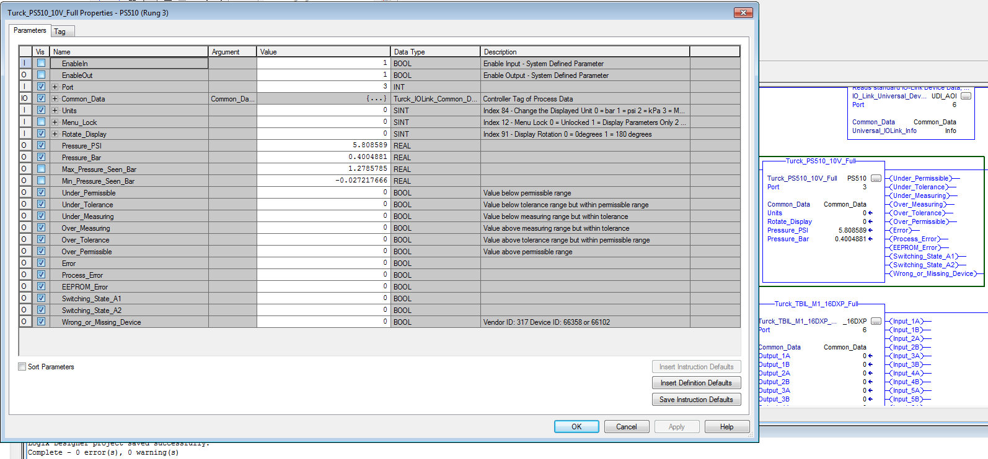

Not Pictured but also controls:

Index 82 – Output 2 Mode must = 0 (No Analog Output)

Index 80 – Process Data Profile must = 2 (Profile 3)